How to use SQL to specify which values should be listed in the prompt for locations | 
Yoel Kortick
Senior Librarian

Question:
I have a prompt in the Fulfillment Subject Area that prompts by field “Location Name” from the folder “Item Location at time of loan”. I want the prompt to only include values from the “Location Name” where the following criteria is met:
- The prompt should only show locations from library ‘Main Library’ and no other libraries.
- Locations of type ‘CLOSED’ should never be included. Here I am referring to the “Location Type” from the folder “Item Location at time of loan”
- Locations with 0 “Loans (Not In House)” from the “Loan” folder should not be included.
- I'd like the prompt to include any new locations that are added in Alma in the future without manual updates. Hence, this should not be a hard coded list.
ONE
Here is our report now before we make and use a prompt:

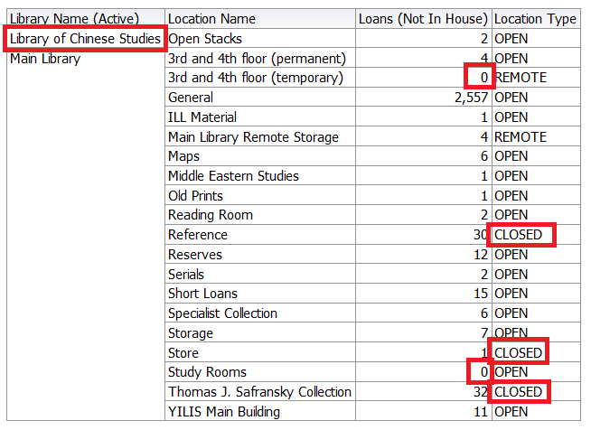

TWO
When we get the list of locations in the prompt it should not include:
- “Open Stacks” because this is in the “Library of Chinese Studies” but not in the “Main Library”.
- “Reference” because this is type “Closed”.
- “Store” because this is type “Closed”.
- “Thomas J. Safransky Collection” because this is type “Closed”.
- “3rd and 4th floor (temporary)” because it has 0 “Loans (Not in House)”.
- “Study Rooms” because it has 0 “Loans (Not in House)”.

THREE
Add the prompt for the “Location Name” from the folder “Item Location at time of loan”. Switch to the “Prompts” tab:

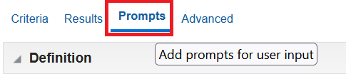

Add the Location Name:

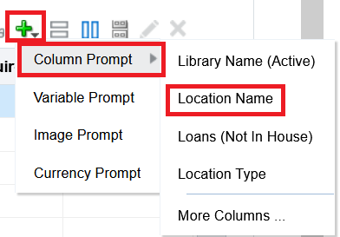

In our case we will make the user input be “Check Boxes” (but that is not relevant to the sql) and click “OK”.

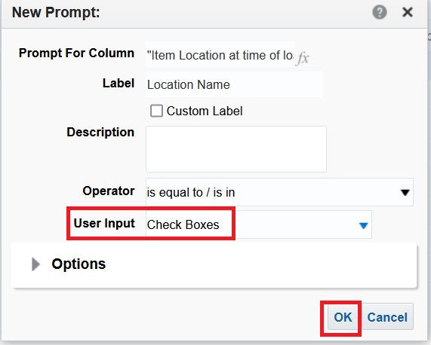

FOUR
See that now by default you have all locations in the prompt:

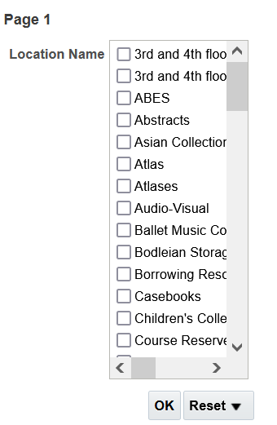

FIVE

We will now change the prompt locations to meet our criteria using the following SQL:

SELECT DISTINCT "Fulfillment"."Item Location at time of loan"."Location Name"
FROM "Fulfillment"
WHERE
"Item Location at time of loan"."Library Name (Active)" = 'Main Library'
AND "Item Location at time of loan"."Location Type" <> 'CLOSED'
AND "Loan"."Loans (Not In House)" > 0
ORDER BY 1

SIX

Add the SQL as follows. First click the triangle next to “Options”.

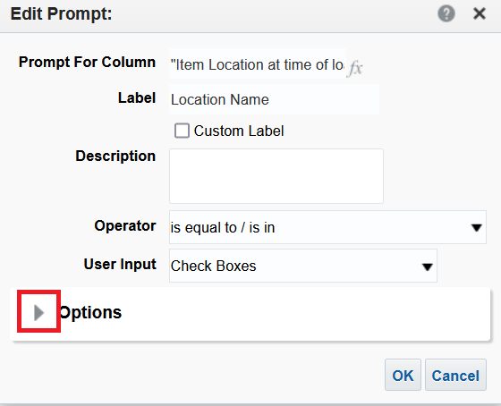

For “Check Box Values” choose “SQL Results” and then enter the above SQL

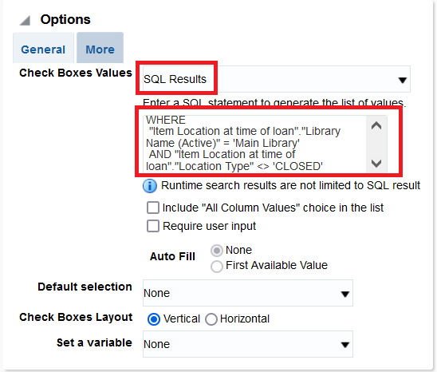

SEVEN
See that the values have changed.
We correctly only have locations which are part of “Main Library”.
For example we do not have “Open Stacks” because it is not part of the Main Library.
We also do not have locations “3rd and 4th floor (temporary)” or “Study Rooms” because they both have 0 “Loans (Not in House)”.

Before | After
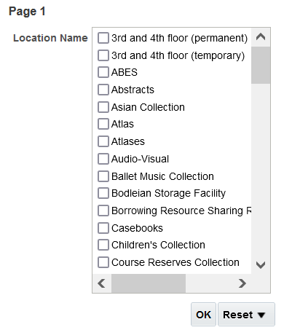 | 